(This report references a Piper PA310350 aircraft.)

This general aviation report reads, "On departure the pilot reported all engine indications were normal prior to rotation. Climbing out of 4,000 feet the right engine lost power. The pilot proceeded with the 'engine out' procedures—determining the right engine was only producing 30 inches of manifold pressure with 8 PSI fuel flow. The pilot returned to (base) and landed without incident." "Maintenance inspected the right engine and found the number one, cylinder injection line broken. AD2011-26-04 was last complied with in May (2012). The aircraft was last inspected 67.7 hours previous to the total time (20,555.3 hours). No defects were found during the inspection."

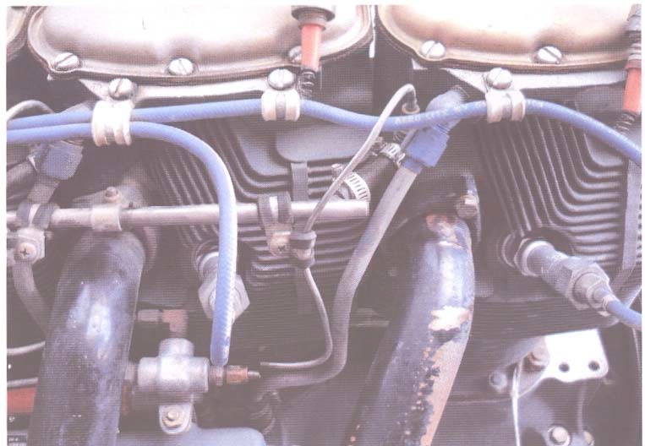

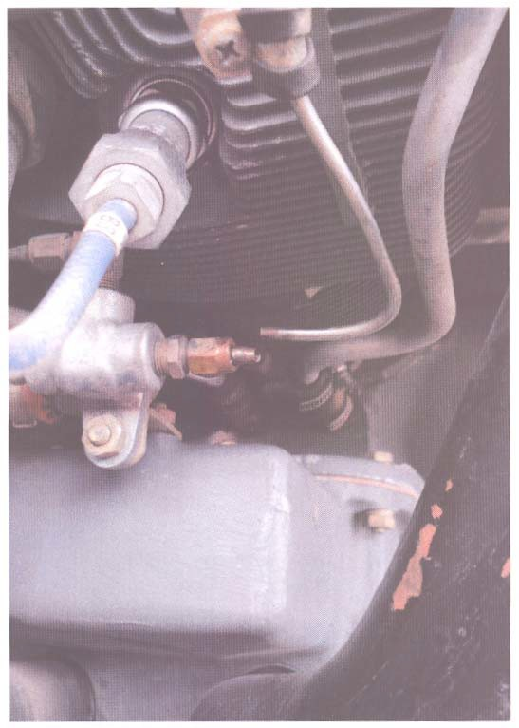

(Fuel Line P/N: LW120980100. Nine of these part numbers can be found in the SDRS database.)

Part Total Time: 20,555.3 hours